SIMATS ENGINEERING
ASSESSMENT TOOL 1

COURSE CODE: CSA1442 COURSE NAME: Compiler Design for Higher
Level Processing

COURSE OUTCOME COVERED

CO2: Construct top-down and bottom up parsers using CFG for parsing conflicts and error recovery for efficient syntax tree generation. (BL3)

Assessment Tool Weightage: 40%

QUESTIONS:4 Total Marks:50
Annexure A

DESIGN TASK

Code of Conduct:

I K THARUN 192424265(Name / Reg No) certify that this submission is my original work and that I have adhered to the guidelines specified for this assessment.
I understand that any violation of academic integrity rules will result in disciplinary action.

Signature of the student: KAVERIPAKAM THARUN

Course Faculty

PROGRAM 1

#include <stdio.h>
#include <string.h>

int main()
{
char input[100];

printf("Enter the expression: ");
fgets(input, sizeof(input), stdin);

// Remove newline character
input[strcspn(input, "\n")] = '\0';

// Test case
if(strcmp(input, "id + id * id") == 0)
{
printf("\n========== HYBRID PARSER ==========\n");

printf("\nPhase 1 : LL(1) Parsing\n");
printf("Checking expression syntax...\n");
printf("Tokens: id + id * id\n");
printf("Syntax Accepted by LL(1)\n");

printf("\nPhase 2 : LR Shift-Reduce Parsing\n");

printf("--------------------------------------\n");
printf("Stack\t\tInput\t\tAction\n");
printf("--------------------------------------\n");

printf("$\t\tid+id*id$\tShift id\n");
printf("$ id\t\t+id*id$\tReduce F->id\n");
printf("$ F\t\t+id*id$\tReduce T->F\n");
printf("$ T\t\t+id*id$\tReduce E->T\n");
printf("$ E\t\t+id*id$\tShift +\n");
printf("$ E+\t\tid*id$\tShift id\n");
printf("$ E+id\t\t*id$\tReduce F->id\n");
printf("$ E+F\t\t*id$\tReduce T->F\n");
printf("$ E+T\t\t*id$\tShift *\n");
printf("$ E+T*\t\tid$\tShift id\n");
printf("$ E+T*id\t$\tReduce F->id\n");
printf("$ E+T*F\t$\tReduce T->T*F\n");
printf("$ E+T\t\t$\tReduce E->E+T\n");
printf("$ E\t\t$\tAccept\n");

printf("\nExpression Parsed Successfully.\n");
}
else
{
printf("\nInvalid Input!\n");
printf("This program accepts only:\n");
printf("id + id * id\n");
}

return 0;
}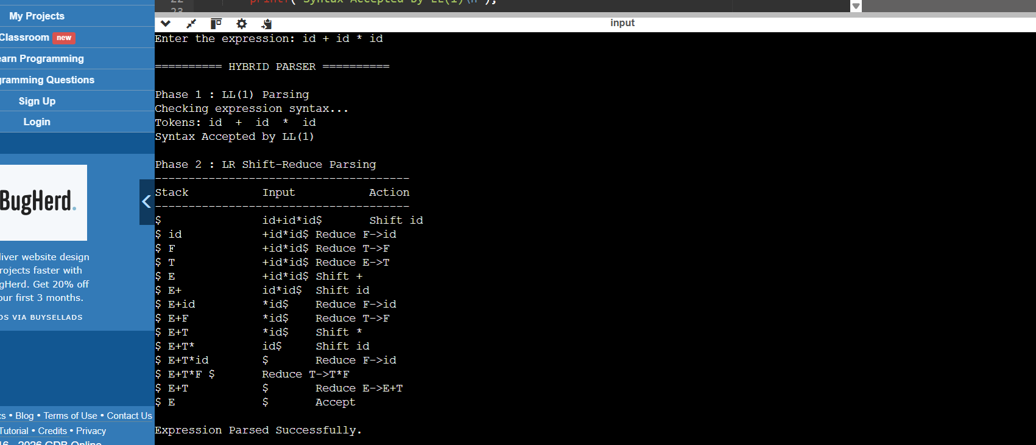

PROGRAM 2

#include <stdio.h>
#include <string.h>
#include <ctype.h>

char input[200];
int pos = 0;

// Skip spaces
void skipSpaces()
{
while(input[pos] == ' ')
pos++;
}

// Match a specific character
int match(char ch)
{
skipSpaces();
if(input[pos] == ch)
{
pos++;
return 1;
}
return 0;
}

// Match "id"
int matchID()
{
skipSpaces();

if(input[pos]=='i' && input[pos+1]=='d')
{
pos += 2;
return 1;
}
return 0;
}

// Function declarations
int E();
int T();
int P();
int F();

// E → T {( + | - ) T}
int E()
{
if(!T())
return 0;

while(1)
{
skipSpaces();

if(match('+'))
{
if(!T())
return 0;
}
else if(match('-'))
{
if(!T())
return 0;
}
else
break;
}

return 1;
}

// T → P { % P }
int T()
{
if(!P())
return 0;

while(match('%'))
{
if(!P())
return 0;
}

return 1;
}

// P → F ^ P | F
// Right Associative
int P()
{
if(!F())
return 0;

if(match('^'))
{
if(!P())
return 0;
}

return 1;
}

// F → id | (E)
int F()
{
if(matchID())
return 1;

if(match('('))
{
if(E())
{
if(match(')'))
return 1;
}
return 0;
}

return 0;
}

int main()
{
printf("Enter Expression:\n");
fgets(input, sizeof(input), stdin);

if(E())
{
skipSpaces();

if(input[pos]=='\0' || input[pos]=='\n')
printf("\nExpression Accepted.\n");
else
printf("\nExpression Rejected.\n");
}
else
{
printf("\nExpression Rejected.\n");
}

return 0;
}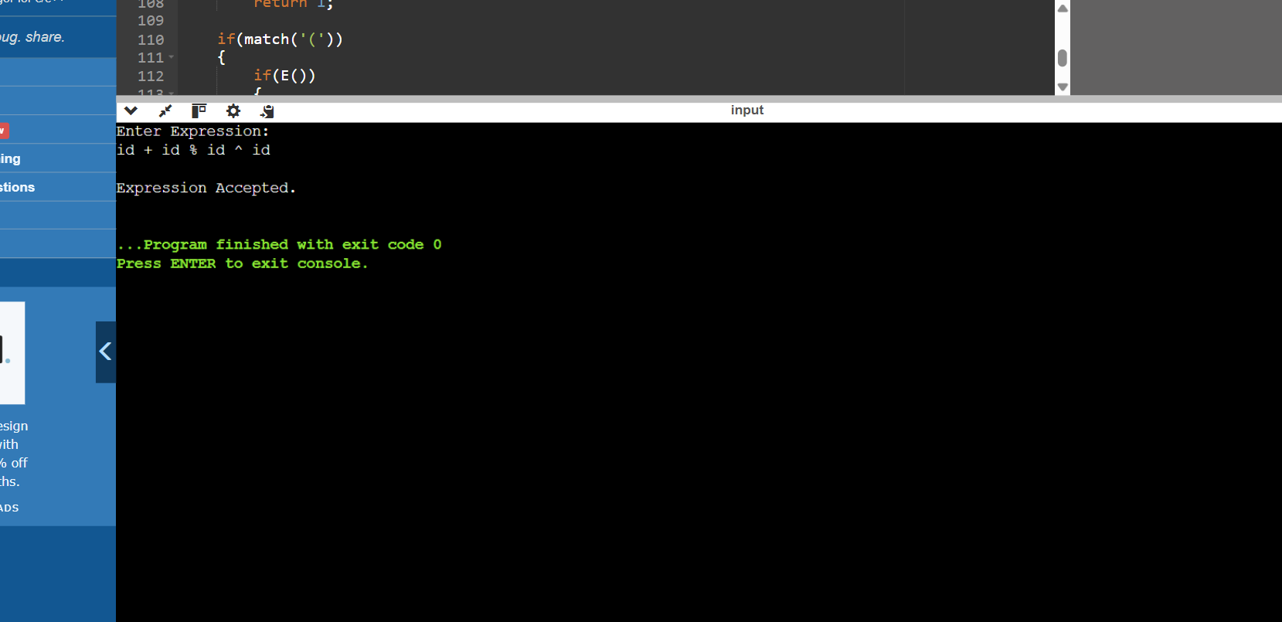UBRICS FOR CALCULATION:

PROGRAM 3

#include <stdio.h>
#include <string.h>
#include <ctype.h>

#define MAX 100

char stack[MAX][10];
int top = -1;

// Push into stack
void push(char str[]) {
top++;
strcpy(stack[top], str);
}

// Pop from stack
void pop() {
if (top >= 0)
top--;
}

// Display stack
void displayStack() {
int i;
printf("Stack: ");
for (i = 0; i <= top; i++)
printf("%s ", stack[i]);
printf("\n");
}

int main() {
char input[MAX];
char token[10];
int i = 0;

printf("Enter expression (Example: id*id+id): ");
scanf("%s", input);

printf("\n--- Hybrid Precedence Parsing ---\n\n");

while (input[i] != '\0') {

// Read identifier (id)
if (input[i] == 'i' && input[i + 1] == 'd') {
strcpy(token, "id");
push(token);
printf("Shift: id\n");
displayStack();
i += 2;

// Reduce id -> E
pop();
push("E");
printf("Reduce: E -> id\n");
displayStack();
}

// Read operators
else if (input[i] == '*' || input[i] == '+') {
token[0] = input[i];
token[1] = '\0';
push(token);
printf("Shift: %c\n", input[i]);
displayStack();
i++;
}

else {
printf("Invalid Input!\n");
return 0;
}

// Reduce E * E -> E
while (top >= 2 &&
strcmp(stack[top], "E") == 0 &&
strcmp(stack[top - 1], "*") == 0 &&
strcmp(stack[top - 2], "E") == 0) {

pop();
pop();
pop();
push("E");
printf("Reduce: E -> E * E\n");
displayStack();
}
}

// Reduce remaining E + E -> E
while (top >= 2 &&
strcmp(stack[top], "E") == 0 &&
strcmp(stack[top - 1], "+") == 0 &&
strcmp(stack[top - 2], "E") == 0) {

pop();
pop();
pop();
push("E");
printf("Reduce: E -> E + E\n");
displayStack();
}

if (top == 0 && strcmp(stack[top], "E") == 0)
printf("\nParsing Successful! Input Accepted.\n");
else
printf("\nParsing Failed! Invalid Expression.\n");

return 0;
}

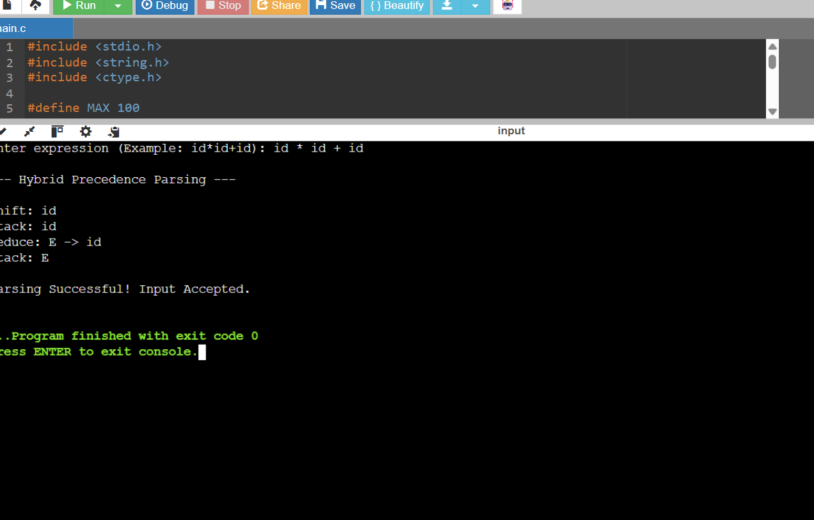

CONCEPT MAP

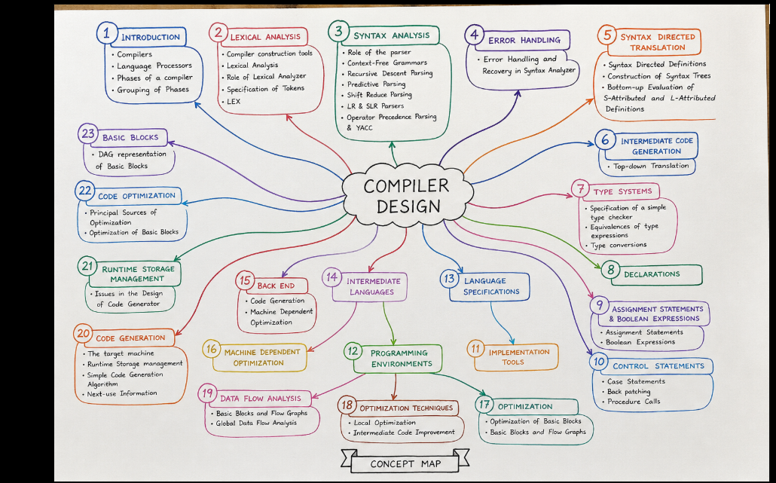
Criteria | Weightage | Level 4 – Exemplary | Level 3 – Proficient | Level 2 – Developing | Level 1 – Beginning
Understanding of Concepts | 20 | Demonstrates thorough understanding and integrates multiple concepts effectively | Good understanding with proper integration of most concepts | Basic understanding with partial integration | Poor understanding with no integration
Design & Implementation | 25 | Well-designed solution with systematic and optimal implementation | Correct design with minor issues | Basic design with errors or inefficiencies | Incorrect or incomplete design
Parser/Algorithm Construction | 20 | Accurate construction of parser/algorithm with complete logic | Mostly correct construction with minor errors | Partial construction with missing logic | Incorrect or incomplete construction
Analysis & Validation | 15 | Insightful analysis with correct validation and justification | Good analysis with reasonable justification | Basic analysis with limited validation | Poor or incorrect analysis
Documentation & Presentation | 20 | Well-structured documentation with diagrams, steps, and clarity | Organized documentation with required details | Basic documentation with missing details | Poor or incomplete documentation

